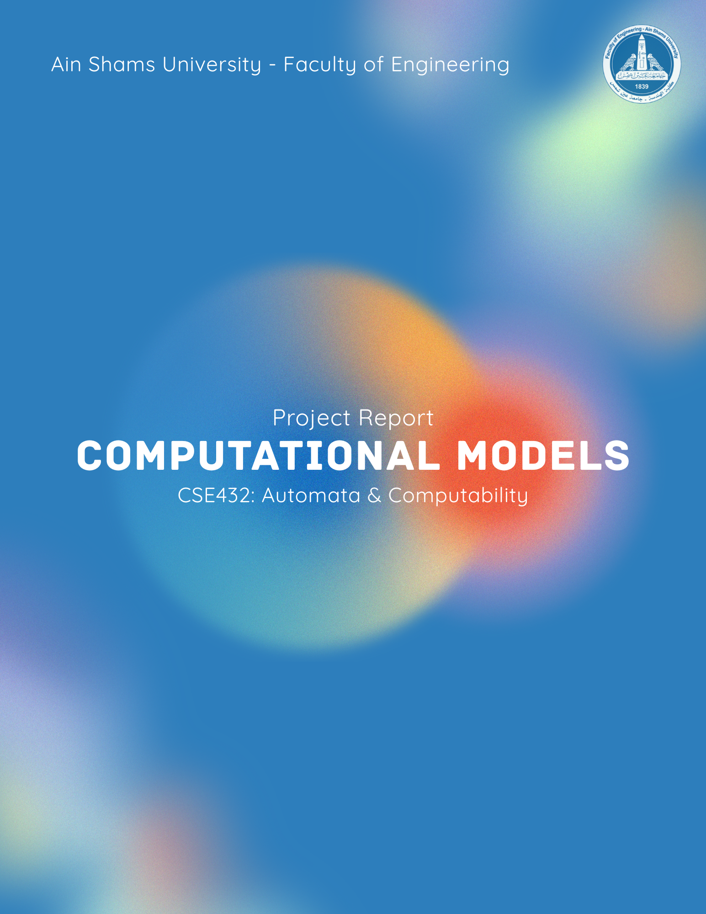

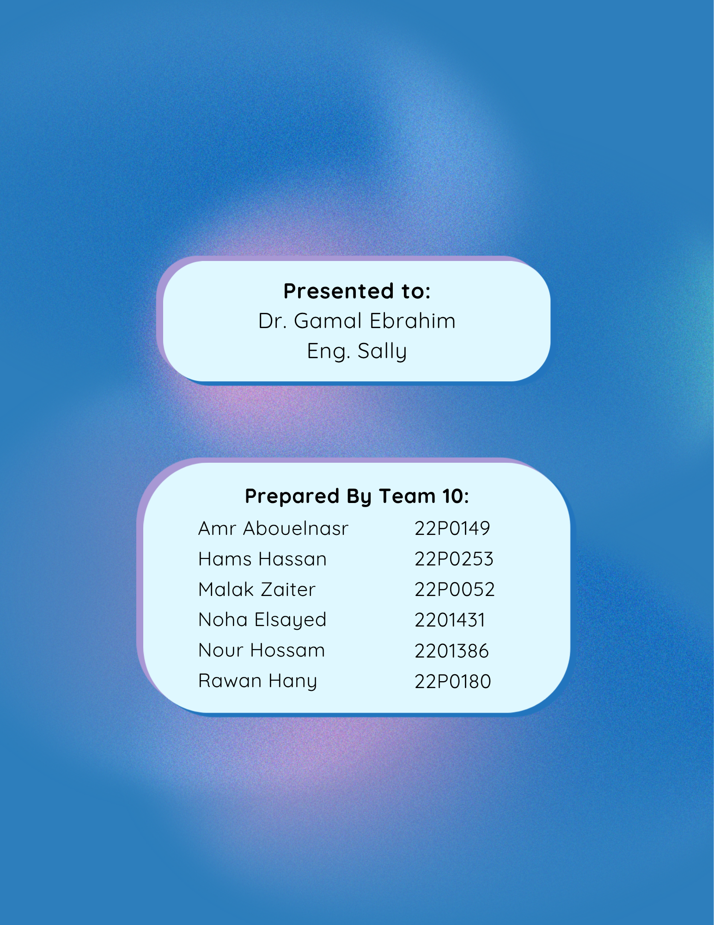
ABSTRACT
Brief overview of the whole project (Part 1 + Part 2)
5–8 lines summarizing objectives, methods, and outcomes
Table of Contents
1. INTRODUCTION VI
1.1. BACKGROUND VI
1.2. OBJECTIVES VI
1.3. REPORT STRUCTURE VI
PART 1: THEORETICAL STUDY 1
2. TURING MACHINES 1
2.1. DEFINITION & COMPONENTS 1
2.2. HOW IT WORKS 1
2.3. PRACTICAL IMPLEMENTATIONS 1
2.4. ADVANTAGES 1
2.5. DISADVANTAGES 1
2.6. PROBLEMS ADDRESSED 1
2.7. LIMITATIONS 1
3. PUSHDOWN AUTOMATA 2
3.1. DEFINITION & COMPONENTS 2
3.2. HOW IT WORKS 2
3.3. PRACTICAL IMPLEMENTATIONS 2
3.4. ADVANTAGES 2
3.5. DISADVANTAGES 2
3.6. PROBLEMS ADDRESSED 2
3.7. LIMITATIONS 2
4. COMPARISON 3
4.1. COMPUTATIONAL POWER 3
4.2. USE CASES 3
4.3. KEY DIFFERENCES 3
5. ADDITIONAL INSIGHTS 4
PART 2: IMPLEMENTATION 5
6. SYSTEM OVERVIEW 5
6.1. PROGRAMMING LANGUAGE USED 5
6.2. DEVELOPMENT ENVIRONMENT 5
6.3. SYSTEM ARCHITECTURE 5
7. PROGRAM 1 5
7.1. PROBLEM DESCRIPTION 5
7.2. ALGORITHM/APPROACH 5
7.3. GUI DESIGN 5
7.4. IMPLEMENTATION DETAILS 5
7.5. SCREENSHOTS 5
8. PROGRAM 2 5
8.1. PROBLEM DESCRIPTION 5
8.2. STATE DESIGN EXPLANATION 5
8.3. TRANSITION DIAGRAM 5
8.4. IMPLEMENTATION DETAILS 5
8.5. SCREENSHOTS 5
9. PROGRAM 3 5
9.1. PROBLEM DESCRIPTION 5
9.2. PDA DESIGN 5
9.3. TRANSITION EXPLANATION 5
9.4. IMPLEMENTATION DETAILS 6
9.5. SCREENSHOTS 6
10. TESTING AND VALIDATION 6
10.1. TEST CASES 6
10.2. RESULTS 6
10.3. ERROR HANDLING 6
11. CHALLENGES & SOLUTIONS 6
12. CONCLUSION 6

No table of figures entries found.

INTRODUCTION

BACKGROUND
What are computational models
Importance of automata theory

OBJECTIVES
What your project aims to achieve

REPORT STRUCTURE
Brief explanation of Part 1 and Part 2

PART 1: THEORETICAL STUDY

TURING MACHINES

DEFINITION & COMPONENTS
Tape, head, states, transition function

HOW IT WORKS
Step-by-step explanation

PRACTICAL IMPLEMENTATIONS
Real-world or theoretical applications

ADVANTAGES
Power, flexibility, universality

DISADVANTAGES
Complexity, inefficiency

PROBLEMS ADDRESSED
Decidable problems, computation theory

LIMITATIONS
Undecidable problems (e.g., Halting Problem)

PUSHDOWN AUTOMATA

DEFINITION & COMPONENTS
Stack, states, transitions

HOW IT WORKS
Stack operations (push/pop)

PRACTICAL IMPLEMENTATIONS
Parsing, compilers

ADVANTAGES
Handles context-free languages

DISADVANTAGES
Limited compared to TM

PROBLEMS ADDRESSED
CFG recognition

LIMITATIONS
Cannot handle context-sensitive languages

COMPARISON

COMPUTATIONAL POWER

USE CASES

KEY DIFFERENCES

ADDITIONAL INSIGHTS
Any extra diagrams, examples, or explanations
Real-world relevance

PART 2: IMPLEMENTATION

SYSTEM OVERVIEW

PROGRAMMING LANGUAGE USED

DEVELOPMENT ENVIRONMENT

SYSTEM ARCHITECTURE

PROGRAM 1

PROBLEM DESCRIPTION

ALGORITHM/APPROACH

GUI DESIGN

IMPLEMENTATION DETAILS

SCREENSHOTS

PROGRAM 2

PROBLEM DESCRIPTION

STATE DESIGN EXPLANATION

TRANSITION DIAGRAM

IMPLEMENTATION DETAILS

SCREENSHOTS

PROGRAM 3

PROBLEM DESCRIPTION

PDA DESIGN

TRANSITION EXPLANATION

IMPLEMENTATION DETAILS

SCREENSHOTS

TESTING AND VALIDATION

TEST CASES

RESULTS

ERROR HANDLING

CHALLENGES & SOLUTIONS
Issues faced during implementation
How you solved them

CONCLUSION
Summary of what you learned
Final thoughts

